Spectrum Usage Plotting in 802.22 Cognitive Radio Networks

Cognitive radio network is a new paradigm that provides the capability to share or use the spectrum in an opportunistic manner. Cognitive radio user has the ability to sense the unused spectrum at any time and location. Based on the availability of the spectrum and other policies, CR user allocates the best available spectrum band. Allocation of a channel not only depends on spectrum availability but also depends on internal and external policies.
CR user shall vacate the spectrum in the presence of any primary user and move to next best available spectrum band.
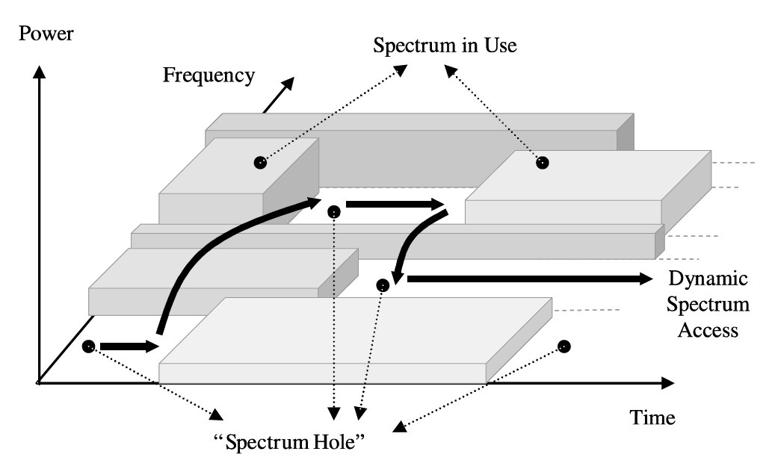
If the specific portion of the spectrum is needed by a licensed user, the communication needs be continued in another vacant portion. CR network has to provide a fair and optimal spectrum allocation method among multiple CR users.

Visualizing Spectrum Usage in 802.22:
To visualize the Spectrum Usage in 802.22, we interface NetSim with MATLAB and pass necessary parameters to MATLAB during runtime. Two set of graphs are plotted in MATLAB:
- Instantaneous Plot of Spectrum Usage (Dynamic graph plotted during runtime).
- Cumulative Plot of Spectrum Usage (Overall graph plotted at the end of the simulation).
Coding Involved:
Modifications are done to the CognitiveRadio Project codes for passing parameters like, Channels in use, Time of arrival, Time of leaving a channel, etc., of both Primary and Secondary users to MATLAB during runtime.
In MATLAB the parameters received are used to plot the Instantaneous Spectrum Usage. These parameters are also logged to individual log files for each device which is finally used to plot the cumulative spectrum usage at the end of the simulation. We use two MATLAB .m files, one for each of the plots.

A Channel_Utilization_Plot.c file is added to the CognitiveRadio project, which contains the following functions:
fn_NetSim_CR_Channel_Utilization_Init()
This function is used to initialize variables required for passing parameters to MATLAB and to initially plot the graph in MATLAB.

fn_NetSim_CR_Channel_Utilization_PU_Plot_Parameters()
This function is used to for updating the portions of the plot which are dedicated to the primary users.

fn_NetSim_CR_Channel_Utilization_BS_Subplot()
This function is used to obtain the base station ID as used in the plot.

fn_NetSim_CR_Channel_Utilization_plot_update_PU_yvalue_Update()
This function is used to periodically update the y-axis values of the Primary Users as they go ON and OFF.

fn_NetSim_CR_Channel_Utilization_SU_Plot_Parameters()
This function is used to for updating the portions of the plot which are dedicated to the secondary users.

fn_NetSim_CR_Channel_Utilization_SU_ystr_Update()
This function is used to periodically update the secondary user device names to be displayed in the plot as they switch channels.

fn_NetSim_CR_Channel_Utilization_plot_update_SU_yvalue_Update()
This function is used to periodically update the secondary user y-axis values to be displayed in the plot as they switch channels.

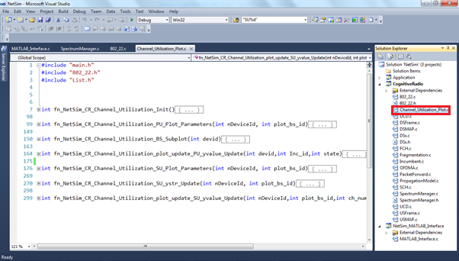
The codes required for plotting the instantaneous spectrum usage during runtime in MATLAB are written to a CR_Channel_Utilization.m file. The codes required for plotting the cumulative spectrum usage at simulation end, in MATLAB are written to a CR_Cumulative_plot.m file. Both these files are added to the CognitiveRadio project directory.

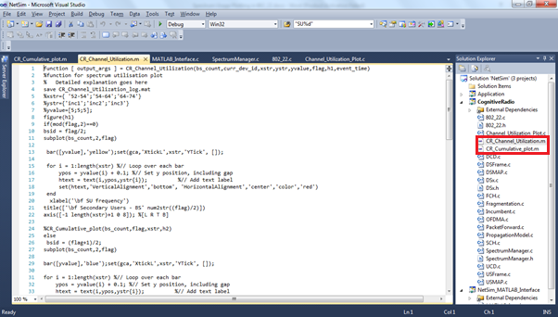

NOTE:
To run this code 32- bit version of MATLAB must be installed in your system.

Steps to run Spectrum usage visualization project Code in NetSim:

- Open Spectrum Usage Plotting Project folder and double click on the Build_Interface_DLL.bat file to obtain a libNetSim_MATLAB_Interface.dll which can be used for interfacing NetSim with MATLAB.
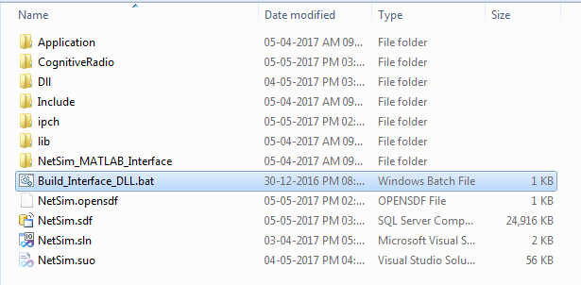
- A command prompt window opens up, asking you to enter the path of the MATLAB’s root directory.
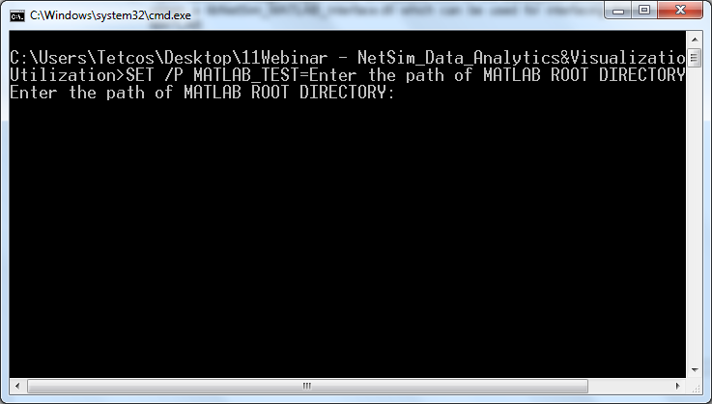

For Example if you have MATLAB 2011 Installed in your system, then your MATLAB root directory would be similar to the following:
“C:\Program Files (x86)\MATLAB\R2011a”

- Provide the path in the command prompt window, within quotes and click on Enter. This will start the process of DLL building.

Note: If you get an error message saying “devenv is not recognized as an internal or external command”, perform the following steps.

- Open the Build_Interface_DLL.bat in an editor like notepad and replace devenv with the path of the devenv.exe file.

Modify:
To:

devenv.exe will be available in IDE folder of the Microsoft Visual Studio 10.0 Install directory.
- After performing the above changes, save the file and rerun.

- Once the build is successful, you will get the message saying Build: 1 Succeeded
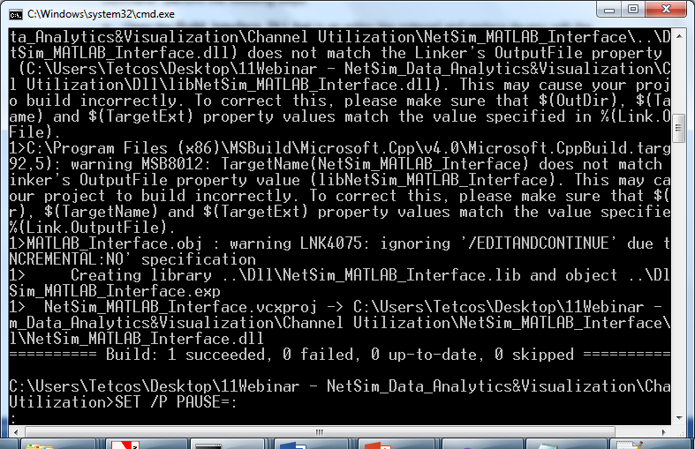

- Now go to the Dll folder inside the Spectrum Usage Plotting project directory and copy the libNetSim_MATLAB_Interface.dll file and paste it in <NetSim_Install_Directory>/bin folder of NetSim.
- Go back to the Dll folder inside the Spectrum Usage Plotting project directory and copy the NetSim_MATLAB_Interface.lib file and paste it in the lib folder of the Spectrum Usage Plotting project directory.
- Now open the codes in Visual Studio 2010 by double clicking on the NetSim.sln file present in the Spectrum Usage Plotting project directory.
- Once the Project is loaded, double click on the Channel_Utilization_Plot.c file listed under the CognitiveRadio project in the Solution Explorer.
- Go to the fn_NetSim_CR_Channel_Utilization_Init() function and change the path:

sprintf(str,"cd 'C:\\Users\\Tetcos\\Desktop\\Channel Utilization\\CognitiveRadio'");
as per the path of the CognitiveRadio folder in your system where the .m files for the project are currently present. (Remember to use double slash ‘\\’ to separate directories)

- Save the changes and right click on the Cognitive Radio project, select Rebuild.
- After successful build you will get the message
Rebuild All: 1 succeeded

- Rename the original libCognitiveRadio.dll file in the bin folder of NetSim.
- Now copy the libCognitiveRadio.dll from the Dll folder inside the Spectrum Usage Plotting Project folder and paste it in the bin folder of NetSim.

- Run NetSim in Administrator mode.

- Create a Network Scenario in Cognitive Radio with 1 or more base stations, primary and secondary users. You can also choose to open a sample Configuration.xml file that is available in the Spectrum Usage Plotting Project folder.

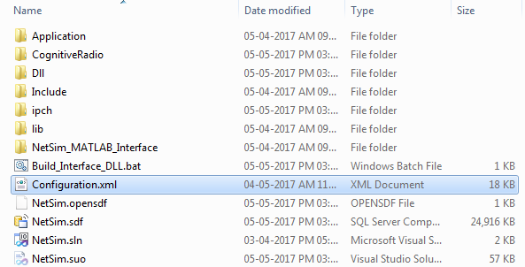

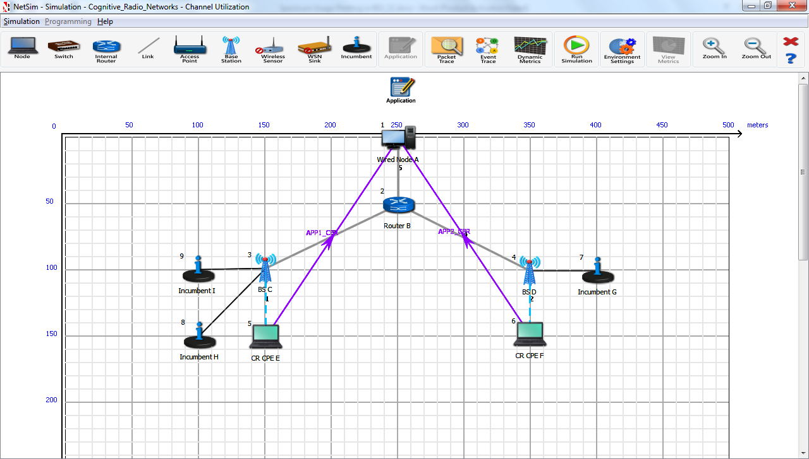

- After this run the simulation. You will observe that MATLAB is initiated automatically as the simulation starts and the instantaneous plot of Spectrum usage is plotted parallel with the simulation.
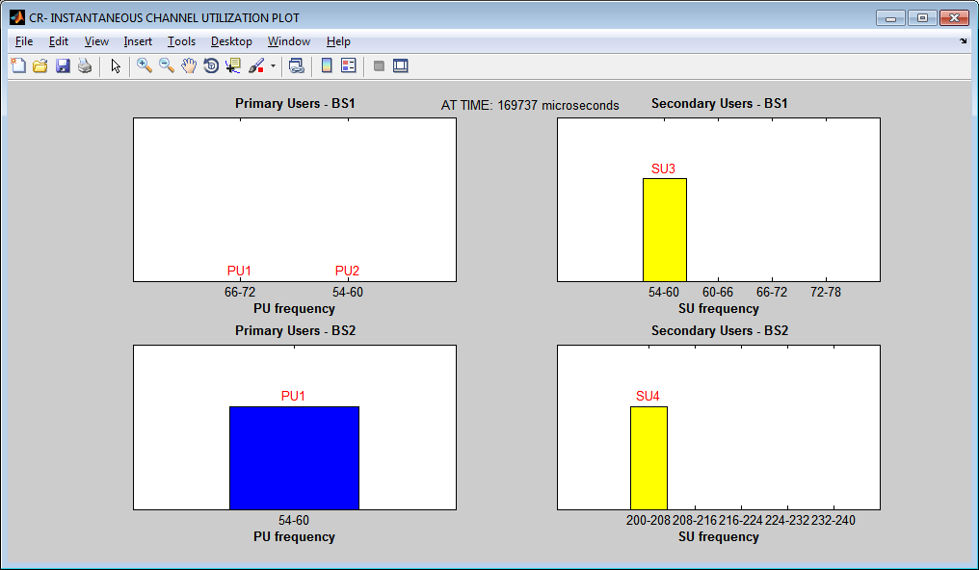
In this plot you have will find a set of plots for each base station in the scenario. For each Base Station, you have a separate plot for the Primary and the Secondary users.
The plot displays the current simulation time and the graphs get re plotted whenever primary users come ON or go OFF and whenever secondary users switch channels, vacate channels, starts using a channel etc.,

- At the end of the simulation the cumulative plot of spectrum usage appears:
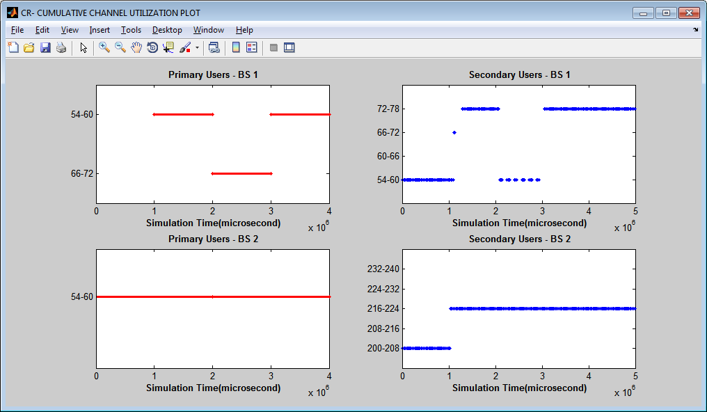
This plot will give you the overall spectrum usage throughout the simulation time. This will help us in understanding the spectral behaviour of the primary and secondary users.

